Goldbeter Model (Actual Model)

# Grid of B high and base

Question: What is the relationship between the top value and the low value of beta as the you cross over the oscillatory region boundary to cause propagation?

To answer this question a grid of combinations of the beta value at the base and a beta value above the threshold was taken according to figure 1.

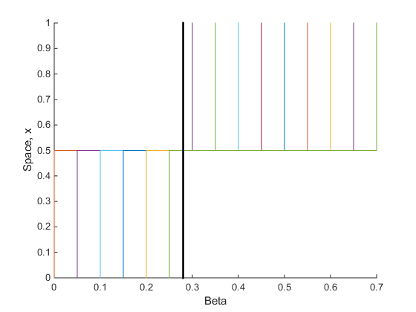

**Possible Betabase values**

**Possible BetaHigh values**

Figure 1: Different beta combinations.

Next the a simulation for each was run to determine if propagation occurred in the previously stable region. Figure 2 shows the values at which propagation occurs (yellow).

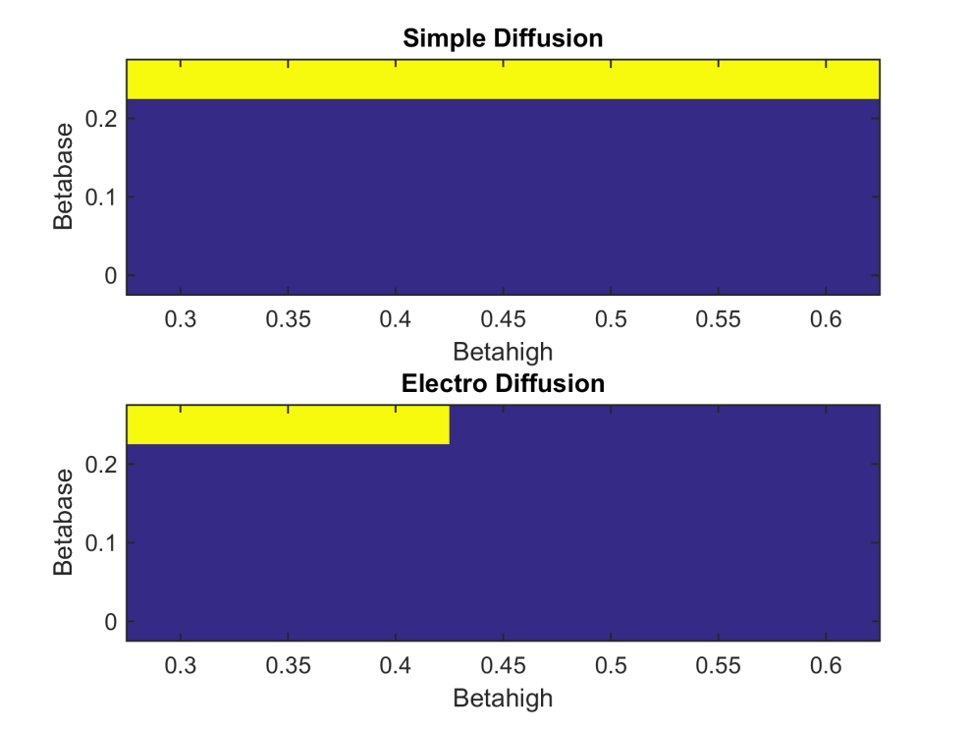

Obviously this scale is not defined enough so a zoom of the section was rerun and gave figure 3

